1.write about compilation steps(4 steps in brief) along with required commands and its options.also brief about Librayr function and system call.
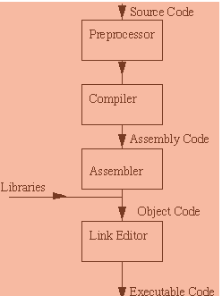

> gcc -e sample.c -o sample.i
>gcc -s sample.i -o sample.s
>gcc -c sample.s -o sample.o

library amd system calls

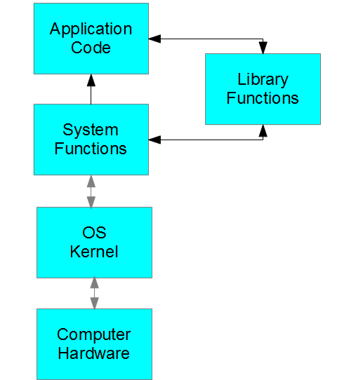

library function:
We can communicate between application and kernel using libraray function and system call.
Libraray function which reside at user space.
System call:
directly communication between userspace and kernel

2. how can debug segmentation fault in c program using GDB? Write at least 10 commands of GDB.

Compile application with -g option, then you have debug symbols in the binary file.

Use the command gdb to open the gdb console.

Use the command file and pass it your application's binary file in the console.

Use the command run and pass it any arguments your application needs to start your application.

Do something to cause your application a Segmentation Fault

Type in the gdb console bt show to get stacktrace in Segmantion Fault time.

